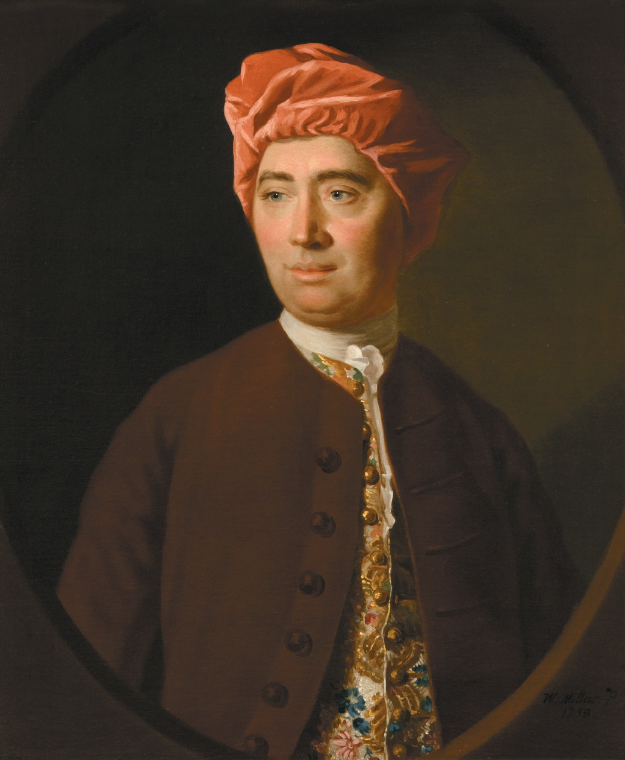
David Hume’s brieven uit Holland

De filosoof, historicus en schrijver David Hume (1711-1776) (1) was samen met Adam Smith een van de meest vooraanstaande Schotten van de 18e eeuw. Hij was een tijdgenoot van Voltaire (1694-1778) (2). David Hume was ten tijde van de Oostenrijkse Successieoorlog (1740-1748) (3) gedurende twee periodes in dienst als privésecretaris en adjudant van Generaal James St. Clair (4).

Eerst in 1746 bij de mislukte aanval op het Franse Quebec door een 5000 man sterke Engelse troepenmacht (niet verder gekomen dan Cork in Ierland vanwege te laat vertrek en tegenwind), die vervolgens werd omgezet in een, eveneens mislukte, aanval op de zuid-Bretonse havenplaats L’Orient. Deze aanval is toen vanwege de grote hoeveelheid ‘comedy of errors’ van zowel de Engelse aanvallers als de Franse verdedigers aan beide zijden van het Kanaal grotendeels uit de geschiedenisboekjes weggehouden. Deze ‘Descent on Brittany’ oftewel ‘Raid on L’Orient’ (5) leidde overigens 10 jaar daarna nog wel tot een schriftelijke polemiek tussen Hume en Voltaire, maar dit terzijde.
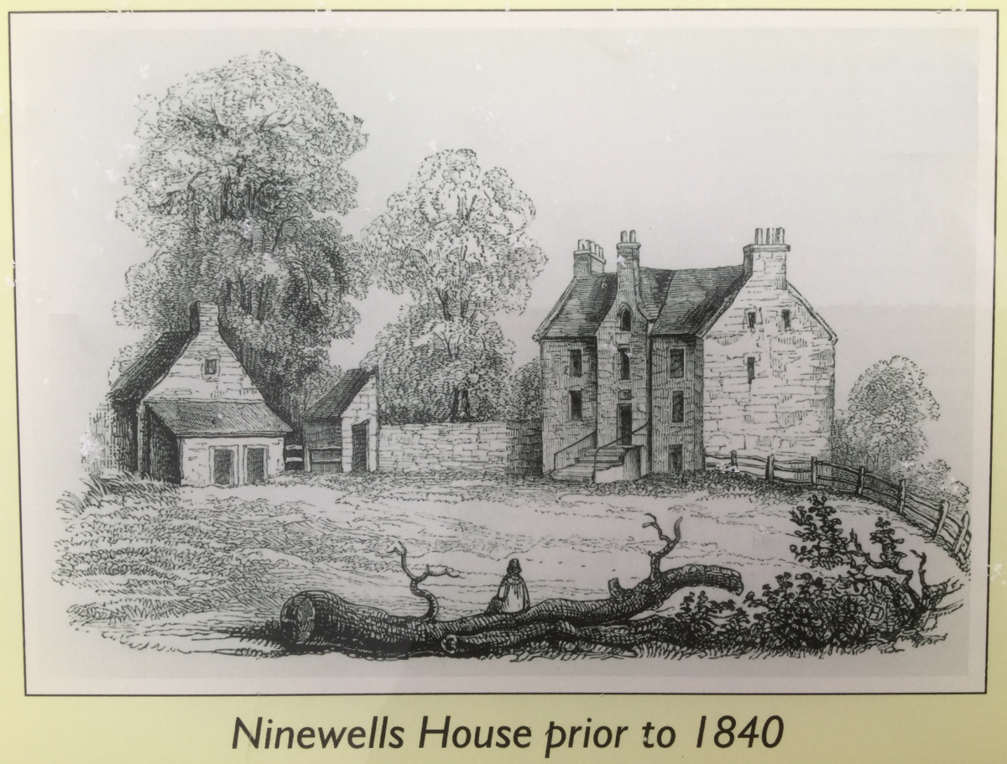
Eind 1747 werd David Hume opnieuw gevraagd door Generaal St. Clair om hem en een klein gezelschap te vergezellen op een diplomatieke missie namens de Britse regering naar de hoven van Wenen en Turijn. Tijdens deze reis in het vroege voorjaar van 1748 besloot David Hume een reisverslag te schrijven en dat in Turijn aan zijn broer John Hume in Ninewells in de Schotse Borders te sturen, die in het bescheiden landhuis van de familie Hume verbleef (6).

Deze familiebrieven zijn later terecht gekomen in het boek ‘Life and Correspondence of David Hume’ door John Hill Burton Esq (1846) (7).

De reis ging per boot van Harwich naar Hellevoetsluis en na een aantal omzwervingen in Holland, met koetsen langs de Rijn en per boot over de Donau naar Wenen en van daar naar Turijn. David Hume heeft vier verslagen opgesteld, die betrekking hebben op het verblijf van drie weken in Holland. Deze vier brieven geven we hier enigszins ingekort weer in de Engelse taal (om de authenticiteit geen geweld aan te doen), omlijst met enige toelichtingen.

Omdat de brieven niet voor publicatie waren bedoeld, maar slechts voor vermaak van zijn broer, kon David Hume ongeremd zijn mening geven over van alles en nog wat. Hij blijkt een even scherpzinnig observator van de Hollandse aard, landschap en politieke verhoudingen als Voltaire met zijn ‘canard, canal, canaille’, dat hier vrij kan worden vertaald met ‘watervogels, water en uitschot’. Maar Hume prijst echter ook aantal typisch Hollandse zaken.

Over zijn twee benoemingen onder Generaal St. Clair spreekt Hume in zijn autobiografie als volgt:

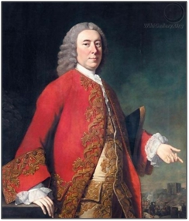
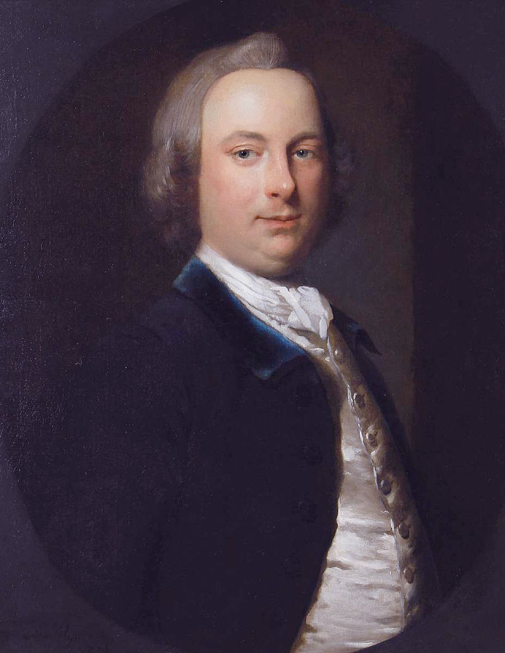
“Next year I received an invitation from the General to attend him in the same station in his military embassy to the courts of Vienna and Turin. I then wore the uniform of an officer and was introduced at these courts as aid-de-camp to the General, along with Sir Harry Erskine (8) and Captain Grant, now General Grant (9).

These two years were almost the only interruptions which my studies have received during the course of my life. I passed them agreeably and in good company; and my appointments, with my frugality, had made me a fortune, which I called independent, though most of my friends were inclined to smile when I said so: in short, I was now master of near a thousand pounds.”

Brief 1 over de reis naar Den Haag: ‘The Hague, 3rd March’

“Dear Brother, – I have taken a fancy, for your amusement, to write a sort of journal of our travels, and to send you the whole from Turin by a messenger whom we are to despatch from thence. I shall endeavour to find little snatches of leisure in the several towns through which we shall pass, and shall give you an account of the appearances of things, more than our own adventures.

We set out from Harwich the day I wrote you last, and in twenty-four hours arrived at Helvoet-Sluys. I had the misfortune to be excessively sick, but the consolation to see an admiral as sick as myself. ‘Twas Admiral Forbes, the most agreeable, sensible sea officer in England.”

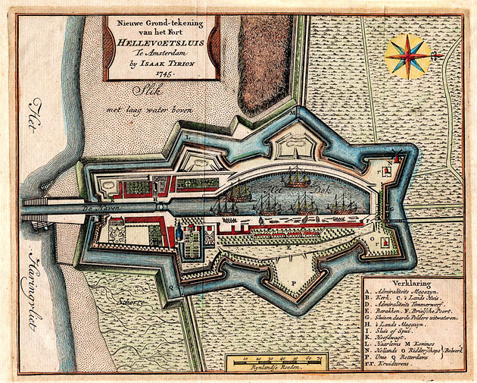
Hellevoetsluis aan het Haringvliet in 1745

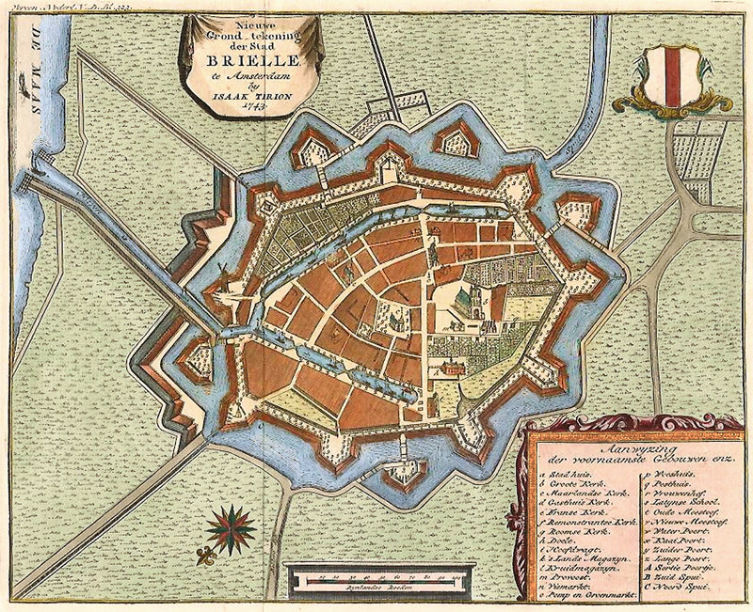
“Harwich and Helvoet are both small sea-port towns, without much trade or any support but passengers; yet the industry, economy and cleanliness of the Dutch have made the latter the much prettier town. The day of our arrival we passed through the Brill and Maeslan-Sluys (10) and lay at Rotterdam. Yesterday we [also] lay at this place.”
Kaart van Den Brielle 1743

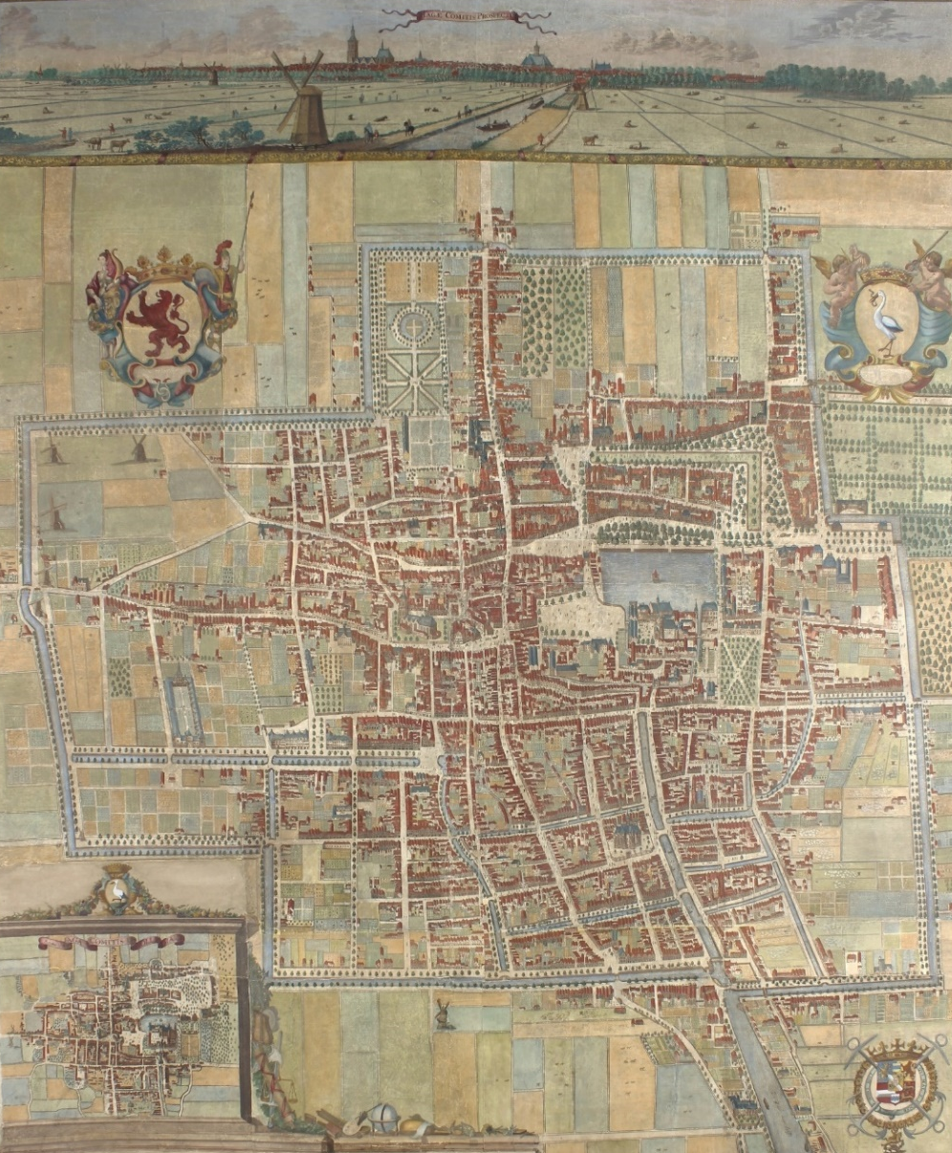
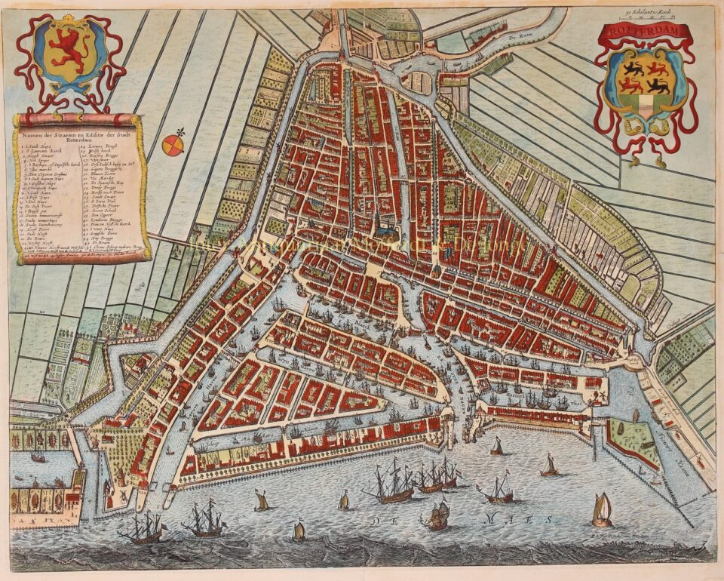
Kaarten van Rotterdam 1690 en
Den Haag met de hofvijver
“Holland has the beauties of novelty to a stranger, as being so much different from all other parts of the world; but not of diversity, for every part of it is like another. ‘Tis an unbounded plain, divided by canals, ditches and rivers. The sea is higher than the country, the towns higher than the sea and the ramparts higher than the towns. The country is in general pretty open, except a few willow trees and the avenues of elm, which lead to their towns and shade the ramparts.

But the country is at present covered with snow, so that it is difficult to judge it. Were the season favourable, the way of travelling would be very pleasant, being along the dykes, which gives you a perfect prospect of the whole country.

I need not describe the beauty and elegance of the Dutch towns, particularly of The Hague, which nothing can exceed.

Rotterdam is also a handsome town. The mixture of houses, trees and ships has a fine effect, and unites town, country and sea in one prospect. Every person and every house has the appearance of plenty and sobriety, of industry and ease. I own, however, that the outside of their houses are the best; they are too slight, full of bad windows, and not very well contrived.”

Brief 2 over de Oranje revolutie: ‘The Hague, 10th March’

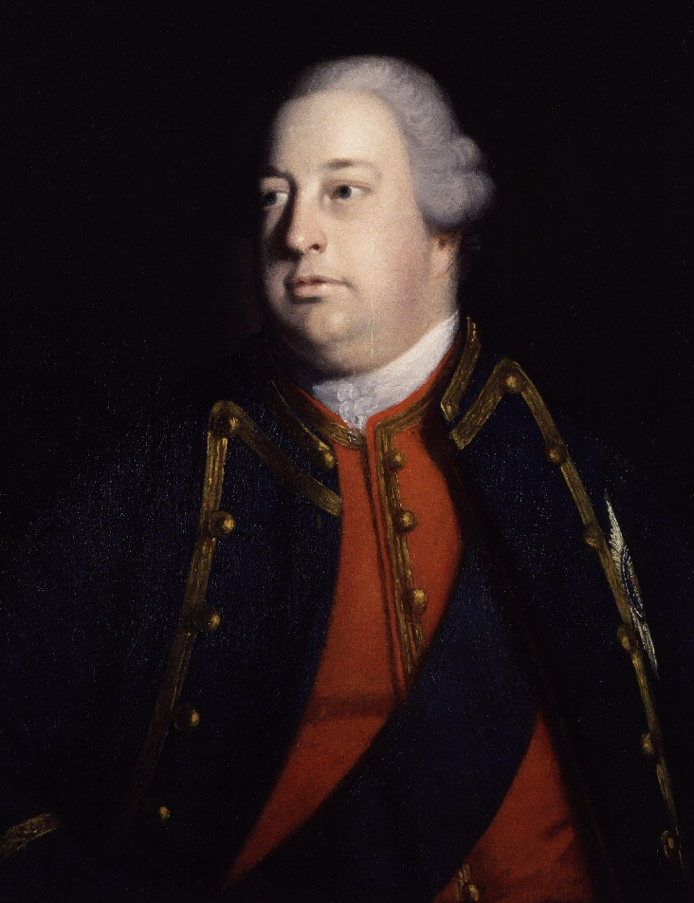
“The General intended to have left this place today, but was detained by the arrival of his Royal Highness (11), which will retard him a day or two longer. We go first to Breda, where the General’s two battalions (12) lie, out of which he will endeavour to form one good healthy battalion to remain here. The other returns to Scotland. We go in a day or two.”

Met Royal Highness wordt William Augustus, Duke of Cumberland, jongste zoon van Koning George II bedoeld. Ondanks zijn onervarenheid was hij in 1745 tot hoofd van de Britse strijdkrachten in de Nederlanden benoemd. Afgezien zijn overwinning in Culloden, waarmee hij in 1746 de Jacobitische opstand in Schotland beëindigde, had hij een onsuccesvolle militaire carrière.
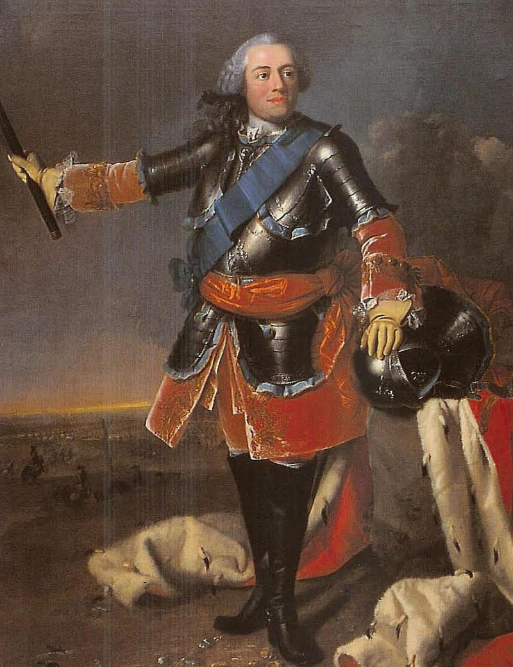
In november 1747 was met de benoeming van Willem IV (1711-1751) (13) een einde gekomen aan het 2e Stadhouderloze tijdperk. De onvrede van het volk had na de val van Hulst (waardoor Commandeur Pieter de la Rocque voor de krijgsraad werd gebracht en blij moest zijn, dat hij het er met levenslange opsluiting in Slot Loevestein vanaf bracht) en Bergen-op-Zoom (na een beleg van twee maanden, waarbij o.a. 1120 van de 1450 manschappen van de Schotse Brigade sneuvelden) in mei en september 1747 nog grotere vormen aangenomen.

“The Prince of Orange’s authority seems firmly established and for the present is as absolute as that of any king in Europe; the favour of the people is the foundation of it. He is certainly a man of great humanity and moderation, but his courage and capacity is perhaps a little more doubtful.

The present emergencies have given him an opportunity of establishing his authority on a firmer bottom than popular favour; viz. (14) on foreign and mercenary forces. The Dutch troops behaved so ill, that the people themselves are willing to see them disgraced, discredited and broke; so that the prince has been able to make great distinctions in favour of foreigners, with the good will of the people, who see the necessity of it.

Great and universal joy appeared on the birth of the young prince while we were there, though all the arrangements were taken to have the young princess (15) succeed, and particularly, she was named colonel of a regiment of the guards.”
“This is a place of little or no amusement, nor has the court made much difference in this respect. No balls, no comedy, no opera. The prince gives great application to business, which, however, they pretend does not advance very much. But this we may venture to say, that Holland was undoubtedly ruined by its liberty and has now a chance of being saved by its prince. Let republicans make the best of this example they can (16).

‘Tis here regarded as a point indisputable, that the old governors were in concert with the French and were resolved, by delivering up town after town and army after army, to have peace, though at the price of slavery and dependence. ‘Tis a pity that the scrupulous and conscientious character of the prince has not allowed him to make some examples of these rascals, against whom ‘tis said, there could have been legal proof.

It was not the mob, properly speaking, that made the revolution, but the middling and substantial tradesmen. At Rotterdam particularly, these sent a regular deputation to the magistrates, requiring the establishment of the Prince of Orange, telling them, at the same time, that if their request was refused, they could no longer answer for the mob. This hint was sufficiently understood and gave example to all other towns in the province.

The only violence offered, was that of the throwing into the canals whoever wore not Orange ribbons. Every yellow rag, woollen, silk and linen were employed; and when they were exhausted, the flowers were made use of; and happily the revolution began in the spring, when the primroses and daffodillys could serve as Orange cockades. To this day every boor, tradesman and schoolboy wears the ensigns of the prince and every street in every village or town has triumphal arches with emblematical figures and Latin inscriptions, such as ‘Vox populi, vox dei’. If this motto be true, the Prince of Orange is the only Jure divino monarch in the universe.

Since the time of Germanicus, deservedly the darling of the Romans, never was a people more fond of one man; surely there entered not the smallest intrigue of his own into his election. There is something of innocence and simplicity in his character, which promotes more his popularity than the greatest capacity.”

Brief 3 over de reis naar Breda en het
actuele verloop van de oorlog: ‘Breda, 16th March’

“We arrived here the day before yesterday, in three days from the Hague, and as the snows were melted after the most violent frost in the world, we discovered Holland in all its native deformity. Nothing can be more disagreeable than the heap of dirt, mud, ditches and reeds, which they call here a country, except the silly collection of shells and clipped evergreens which they call a garden (17).
It gave us a sensible pleasure, as we came near Breda, to find ourselves on a dry barren heath and to see something of human habitation. I have heard that Holland, after many struggles between land and water who should be master of it, had at last agreed to share it betwixt them. If so, the land has come by much the worst bargain and has much the smallest share of the possession.

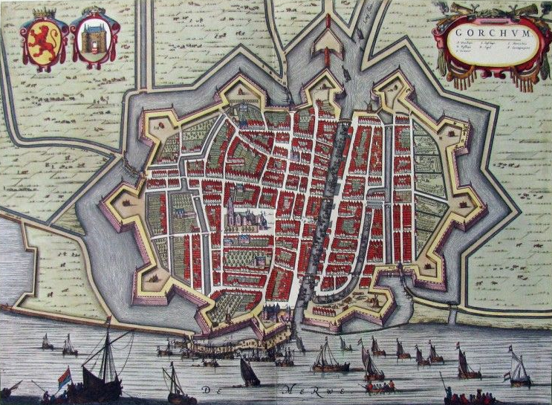
I am told, however, that Holland is a pleasant enough habitation in the summer: though even that beauty lasts a very short time; for, during the latter end of the summer and during the harvest, the canals send forth so disagreeable and unwholesome a smell, that there is no enduring at it.
Kaart van Gorcum

We passed over the Maese at Gorcum (18), where it is above half a mile broad; and as the ice had been softened by a thaw of three or four days, we were obliged to make use of an ice boat. (19) The operation is after this manner: you place yourself on your ice boat, which is like an ordinary boat, except only that it runs upon two keels, shod with iron.

Three or four men push you along in this boat, very cleverly, as long as the ice will bear you: but whenever that fails, plump down you go into the water of a sudden. You are very heartily frightened. Then men are wet, up to their neck sometimes; but, keeping hold of the boat, leap in, row you through the water, till they come to ice that can bear. There they pull you up, run along with you, till you sink again; and so they renew the same operation.”

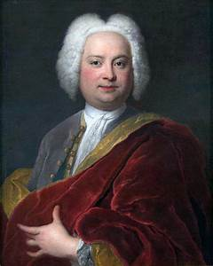
“The night we came to Breda we supped with Lord Albermarle (20), who told us, that we might hear of a battle in the neighbourhood; and accordingly, in about an hour, a messenger came in with the news. You have no doubt heard of it. It was the attack of a convoy to Bergen-op-Zoom, escorted by about 5000 French, where 400 were killed and about 1000 taken prisoners. Next day the prisoners were led thought the town. Such a pitiful-looking fellows never man set eye on. France is surely much exhausted of men, when she can fill her armies with such poor wretches. We all said, when they passed along, are these the people that have beat us so often? (21)

I stood behind Lord Abermarle. One of the ragged scarecrows, seeing his Lordship’s star and ribbon, turned about to him and said very briskly, ‘Aujourd’hui pour vous, demain pour le roi.’ If they have all this spirit, no wonder they beat us.
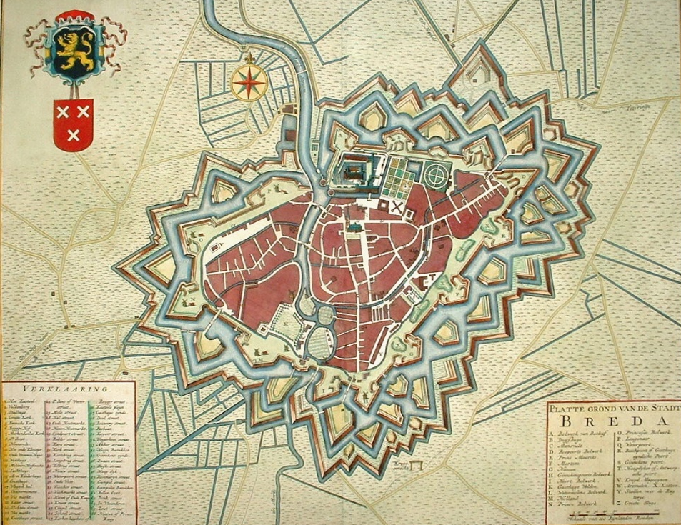

Kaart van Breda van Covens & Mortier, 1748

Breda is a strong town, though not near as so strong as Bergen-op-Zoom. It is almost surrounded by water , and inaccessible except in one place, by which it will be taken, if the 206.000 men, whom we have in the field this year in the Low Countries, cannot save it.”

“The French certainly have laid their account to give up Flanders by the peace; they squeeze, oppress, tax and abuse the Flemings so much, that ‘tis evident they consider them not as subjects. They are also said to be pretty heartily tired of the war, notwithstanding of their great successes. I suppose the loss of their trade pinches them; so that there are some hopes of a peace, which may not be altogether intolerable.”

Brief 4 over de reis naar Nijmegen: ‘Nimeguen, 20th March’
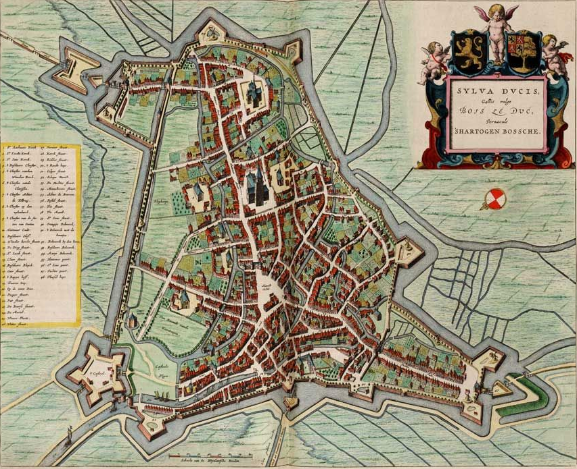
Kaart van ‘s-Hertogenbosch

“We have come from Breda in two days, and lay last night at Bois-le-Duc, which is situated in the midst of a lake and is absolutely impregnable. That part of Brabant, through which we travelled, is not very fertile, and is full of sandy heaths. Nimeguen is in the Gueldre, the pleasantest province of the seven, perhaps of the seventeen. The land is beautifully divided into heights and plains and is cut by the branches of the Rhine.

Nimeguen has a very commanding prospect and the country below it is particularly remarkable at present because of the inundation of the Wahal [sic], a branch of the Rhine, which covers the fields for several leagues; and you see nothing but the tops of the trees standing up amidst the waters, which recalls the idea of Egypt during the inundation of the Nile.

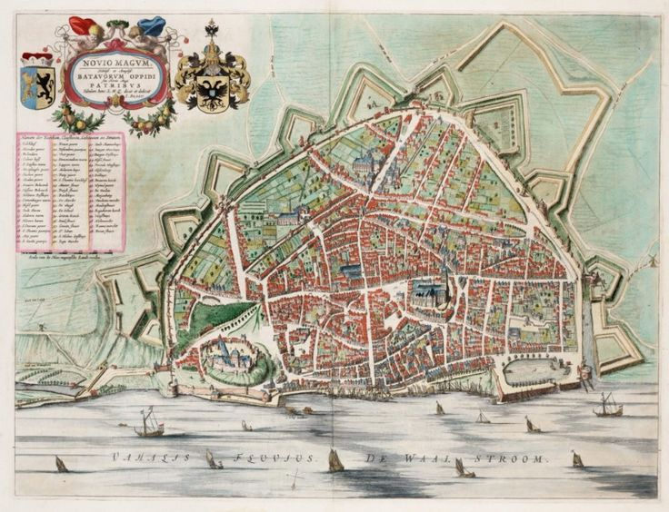
Oude kaart van Nijmegen van Bleau uit 1669

Nijmeguen is a well-built town, not very strong, thought surrounded with a great many works. Here we met our machines (22), which came hither by a shorter road from The Hague. They are a berlin for the general and his company and a chaise for the servants. We set out tomorrow and pass by Cologne, Frankfurt and Ratisbon, till we meet with the Danube, and then we sail down that river for two hundred and fifty miles to Vienna.”

De volgende brief is geschreven in Keulen op 23 maart en valt daarmee buiten het bestek van dit overzicht. De laatste korte brief is geschreven in Turijn op 16 juni. Het vervolg van de reis valt te lezen in het boek aangeduid in voetnoot 7.

Voetnoten:

(1) David Hume - Wikipedia
(2) Voltaire - Wikipedia
(3) Oostenrijkse Successieoorlog - Wikipedia
(4) James St Clair - Wikipedia
(5) Raid on Lorient - Wikipedia
(6) David Hume’s Family (3) - Chirnside Common Good Association
(7) The Project Gutenberg eBook of Life and Correspondence of David Hume, Volume I, by John Hill Burton.
(8) ERSKINE, Sir Henry, 5th Bt. (1710-65), of Alva, Clackmannan. | History of Parliament Online Zijn moeder was een zuster van Generaal James St. Clair
(9) GRANT, James (1720-1806), of Ballindalloch, Banff. | History of Parliament Online
(10) Den Brielle en Maassluis
(11) Prince William, Duke of Cumberland - Wikipedia Zoon van de Britse Koning George II
(12) 1e en 2e Battalion van het Royal Regiment, waarvan James St. Clair sinds 1737 commandant was
(13) Willem IV van Oranje-Nassau - Wikipedia Zijn vrouw Anna van Hannover was een dochter van de Britse Koning George II
(14) namelijk
(15) https://nl.wikipedia.org/wiki/Willem_V_van_Oranje-Nassau Door de geboorte van Willem Batavus, de latere Willem V, op 8 maart 1748 was zijn oudere zus niet meer de eerste in de lijn van troonopvolgers
(16) Willem IV verspeelde nog voor zijn voortijdige dood in 1751 al veel krediet door hervormingen weer terug te draaien en het zwakke beleid van de laatste stadhouder Willem V leidde tot de patriottentijd, die uitmondde in zijn vlucht naar Engeland en het uitroepen van de (Franse) Bataafse Republiek in 1795
(17) Geen liefhebber van het riviergebied in winter dus. Ook andere ideeën over tuininrichting
(18) Bedoeld wordt de oversteek van de Merwede van Gorinchem naar Woudrichem
(19) Voor zover bekend zijn lokale historici onbekend met boten voorzien van sledes
(20) Willem van Keppel, 2nd Earl of Albemarle - Wikipedia, adjudant van de Duke of Cumberland
(21) Inderdaad hadden de Fransen onder Maarschalk Saxe en Generaal von Lowendahl vrijwel alle veldslagen gewonnen, maar dit werd in het vredesakkoord van Aken later dar jaar niet in territoriale claims omgezet
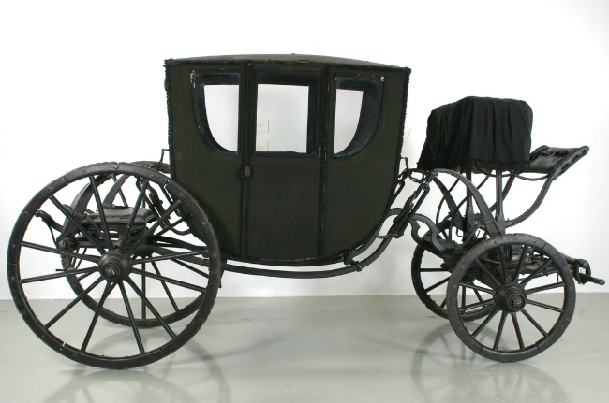
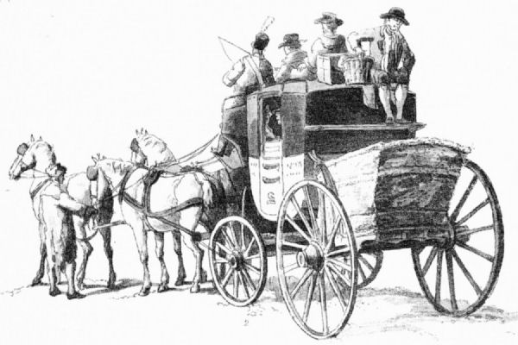
(22) Een berlin is in het algemeen een gesloten rijtuig voor twee personen (zie afbeelding links). Bij een chaise voor het personeel zou je je de rechterafbeelding kunnen voorstellen. Vrouwen binnen, mannen achterop.

MEAvB, 10 februari 2021

